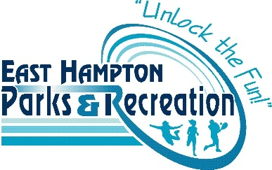
Seamster Park Playground Construction
Volunteer Release and Waiver of Liability Agreement
Tuesday, August 6th – Sunday, August 11th, 2019

In consideration of voluntarily participating in the construction of Seamster Park Playground on the Town of East Hampton property at Seamster Park located at 20 Smith Street, East Hampton CT (hereinafter referred to as the “Construction Project”), I hereby agree to this Volunteer Release and Wavier of Liability Agreement (the “Agreement”).

I recognize that the Construction Project may involve physical activity and may carry a risk of personal injury and may cause me physical or emotional discomfort. I further recognize that there are natural and manmade hazards, environmental conditions, diseases and other risks, which in combination with my actions in the Construction Project can cause injury to me. I state that I am free from any known health conditions that could prevent me from participating in any of the activities associated with the Construction Project. I further state that I am sufficiently physically fit to participate in the activities of this program. I acknowledge that my participation is voluntary and done at my own risk, and I voluntarily assume all risk of loss, damage or injury that may be sustained while participating in the Construction Project.
I further agree to release, indemnify, and hold harmless the Town of East Hampton, its agencies, departments, officers, employees, agents, insurers, representatives, elected officials, affiliates, directors, servants, volunteers, members, sponsors and/or officials and staff of any such entity or person, their representatives, agents, affiliates, directors, servants, volunteers and employees from any and all liability, claims, demands, actions and causes of actions whatsoever for any loss, claim, damage, injury, illness, attorneys’ fees or harm of any kind or nature to me arising out of any and all activities associated with my participation in the Construction Project.

This Agreement is granted, without limitation in favor of the Town of East Hampton, the playground steering committee, and respective officials, members, employees, representatives, directors, sponsors, and organizers, and other participants in the Construction Project.

I have read and understood everything written above, and I voluntarily signed this Agreement. If the participant is under 18 years of age, the signature of a parent or guardian of the volunteer is required in addition to that of the volunteer.

_______________________________________ Date: _________________________
Signature of Volunteer

_______________________________________ _________________________________
Printed Name of Volunteer Parent/Guardian Signature (if applicable)

_______________________________________
Age

